How to test this API?

**Step 1**: This API can be tested with [Postman](https://www.getpostman.com/) app to mimic client side requests. Here you can make simple HTTP requests with custom bodies and parameters.

**Step 2**: Under Body heading, Enter key value pairs for example {Title: Abc, body:noteDescription}.

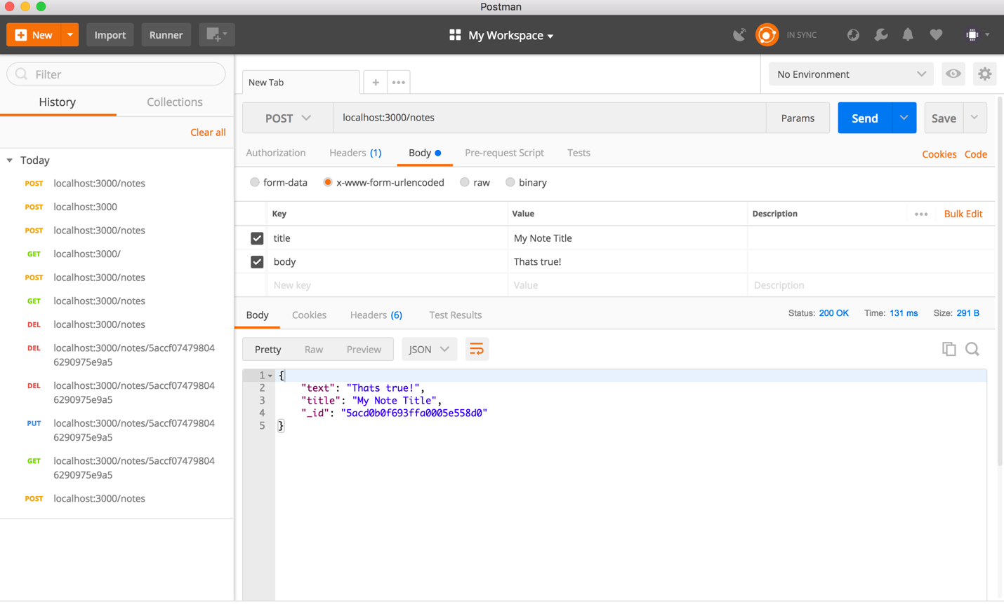

**Step 3**: Save them. Now enter the address localhost:3000/notes. This will prompt out the key and value pairs entered in JSON format. That’s a POST request.

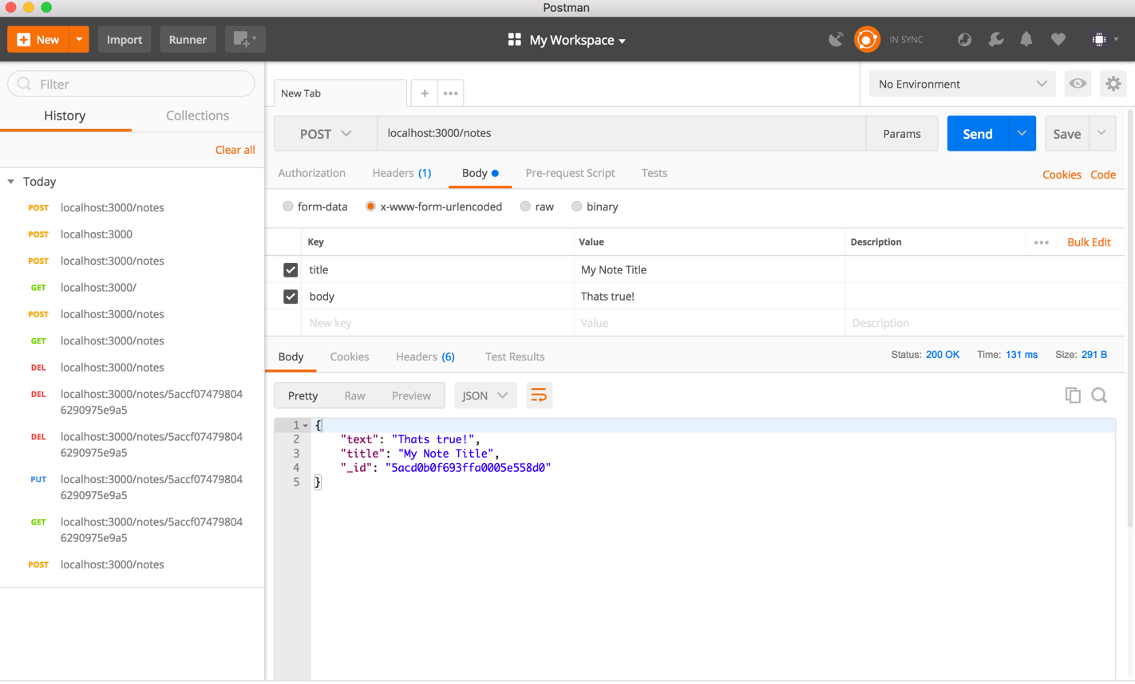

**Step 4**: An id is generated on which can serve GET request. Enter ‘localhost:3000/notes/id’. Here for example it is localhost:3000/notes/5acd0b0f693ffa0005e558d0. This will output the object with this id.

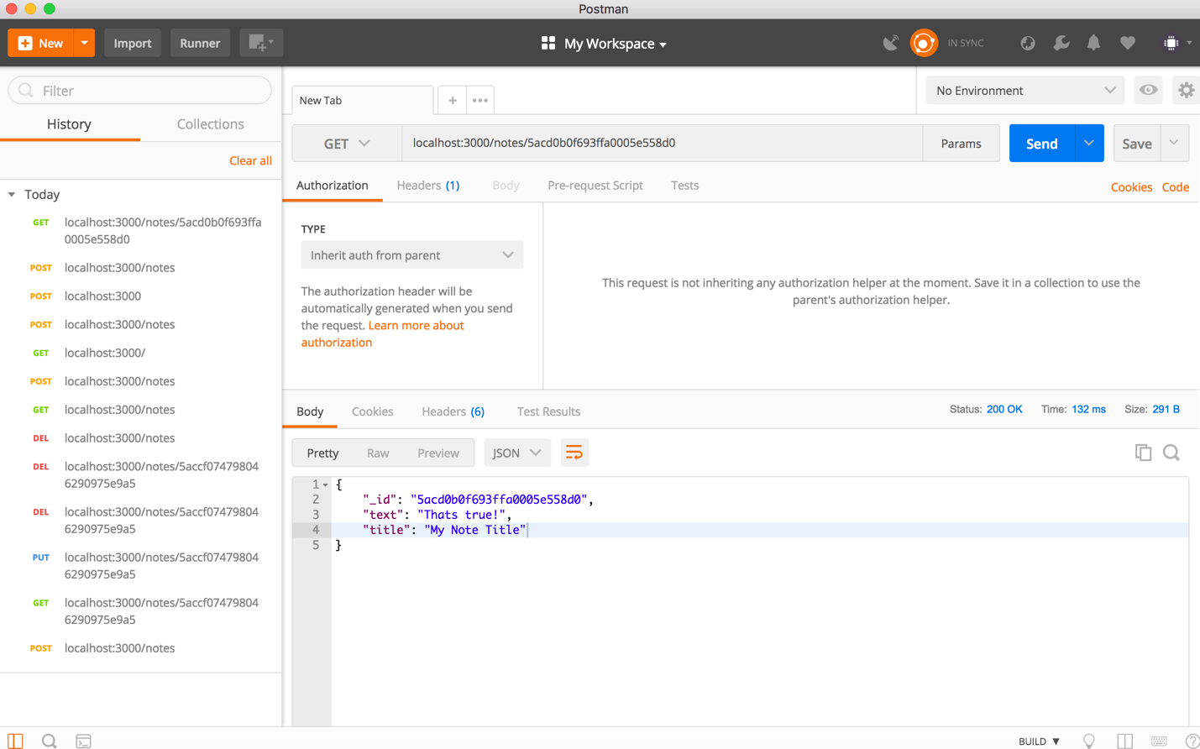

**Step 5**: Similarly PUT and DELETE requests can also be acted upon using same address with ID as shown in the screenshots below.

(PUT request)

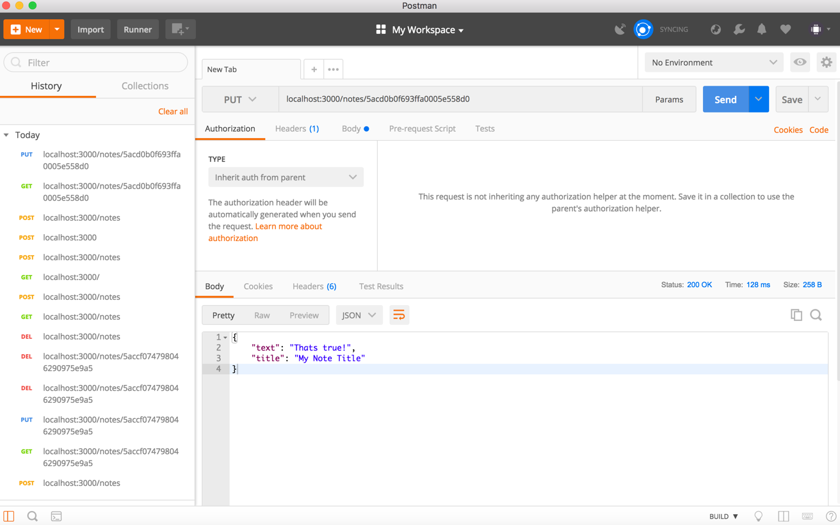

(Delete Request)

